**Branch: - Computer Science and Engineering Class: - III Year**

**Subject: - C-Skill Lab-IV Sem: - VI**

**Teacher Manual**

**PRACTICAL NO. 7**

**Aim:** Push local repository to GitHub using Git.

## **Git Hub:**

GitHub is a cloud-hosted Git management tool. Git is distributed version control, meaning the entire repository and history lives wherever you put it. People tend to use GitHub in their business or development workflow as a managed hosting solution for backups of their repositories. GitHub takes this even further by letting you connect with coworkers, friends, organizations, and more.

**Prerequisites :**

To initialize the repository and push it to GitHub you need:

1. [A free GitHub Account](https://github.com/)
2. [Git installed on your local machine](https://www.digitalocean.com/community/tutorials/how-to-contribute-to-open-source-getting-started-with-git" \l "check-if-git-is-installed)

Steps:

1. Create a new GitHub Repository.

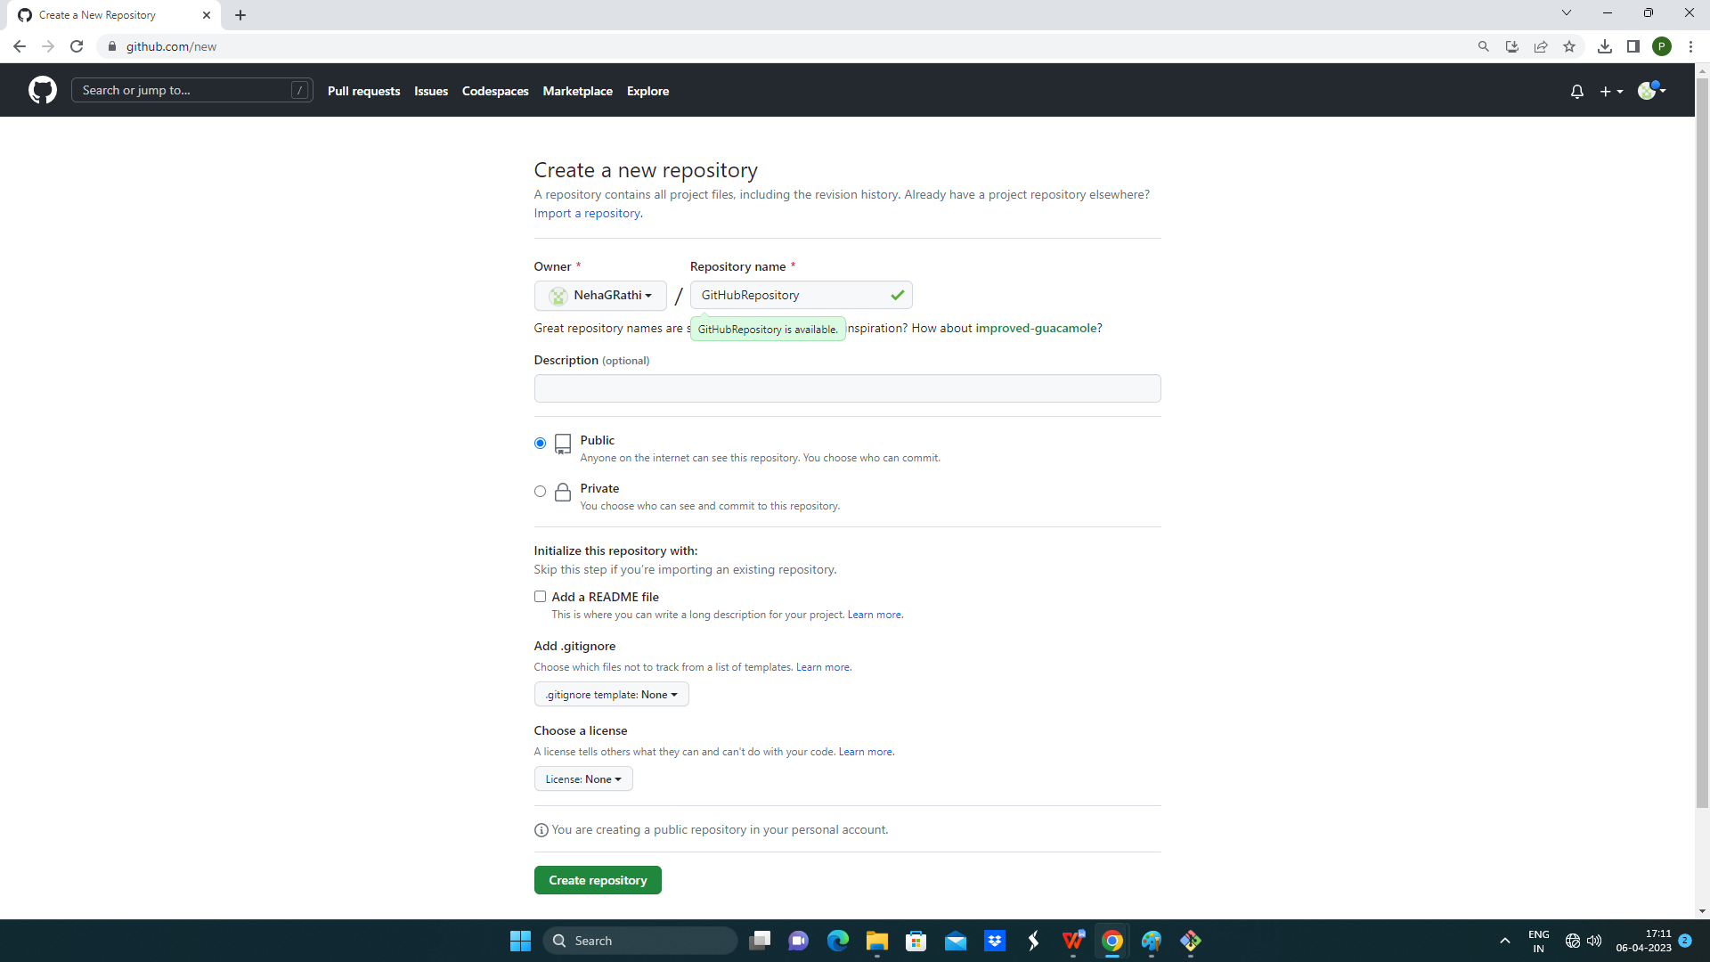

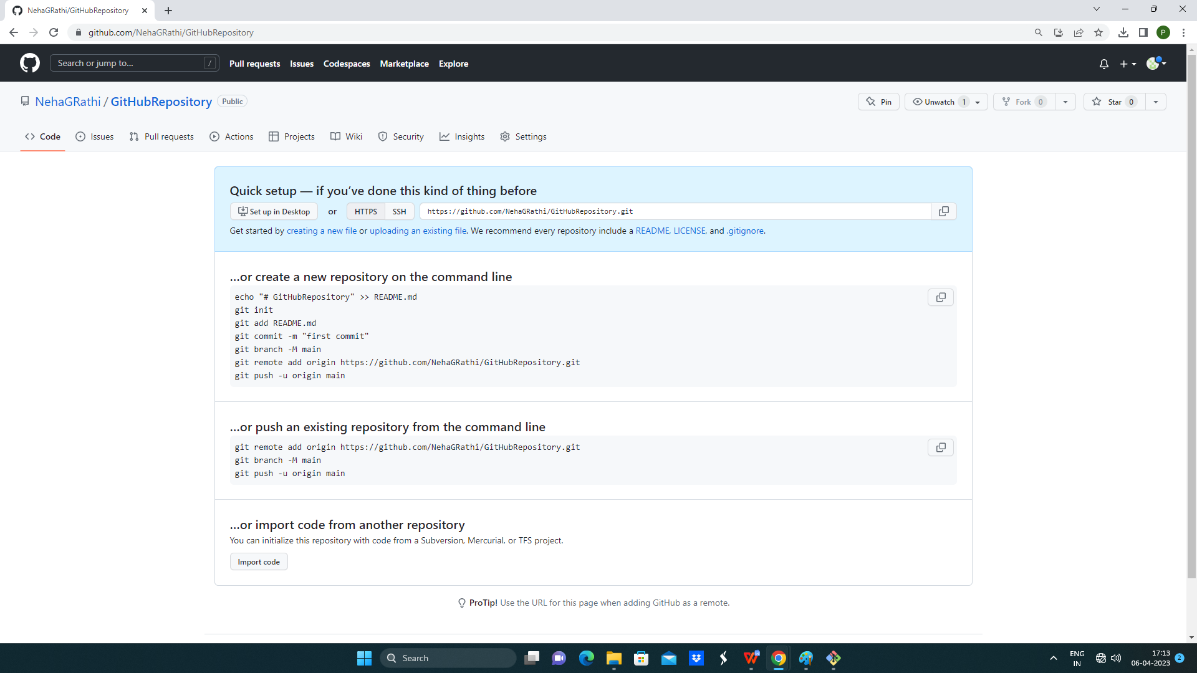

1. Add a new remote origin.

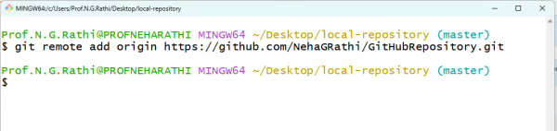

1. Push to GitHub

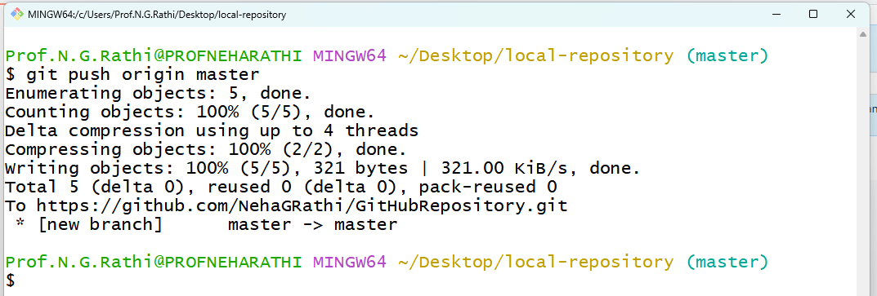

1. Refresh the github webpage.

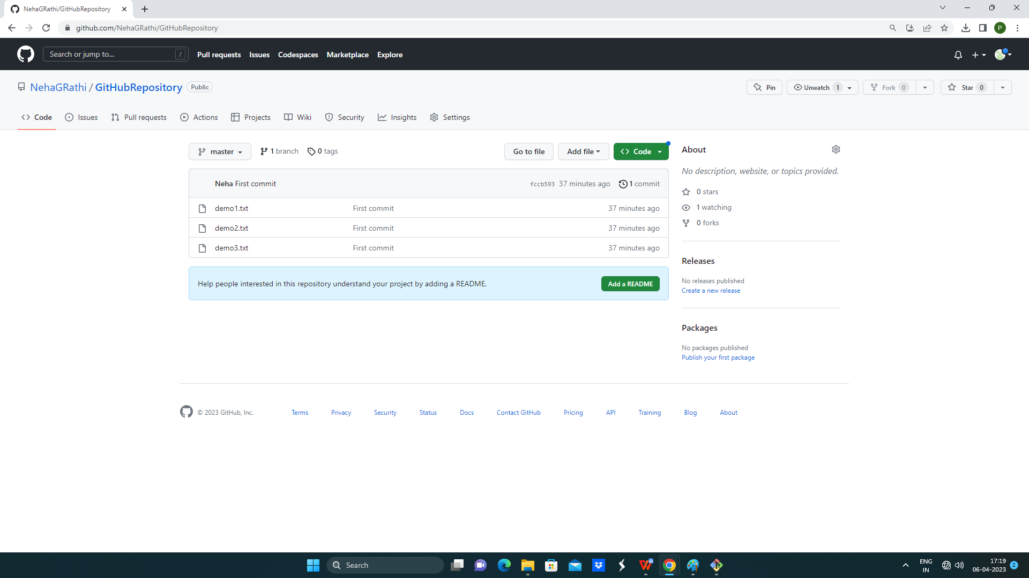

**Conclusion:** Thus I have pushed local repository to GitHub using Git.